Lab 12 – Half Adder (Binary Addition)
Purpose
The purpose of this lab is to better understand how two binary gates would be work together. Also this lab helps get a better knowledge of how inputs have an effect on two combined binary gates.
Equipment
Name | Quantity | Picture | Prices (Canadian Dollars)
7486 IC chip (Integrated Chip) | 1 | 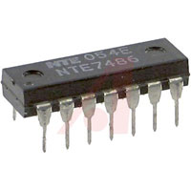 | $1.49
7408 IC chip (Integrated Chip) | 1 | 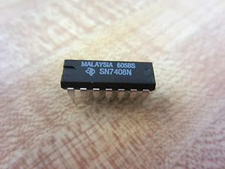 | $0.89
SK-50 Breadboard | 1 | 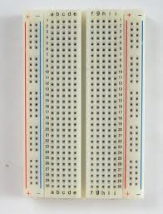 | $6.04
LED (Light Emitting Diode) | 2 |  | $0.10
470 ohms Resistor | 2 | 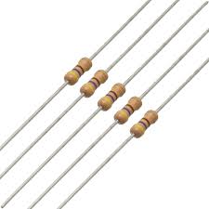 | $0.14
Jumper Wires | 8 |  | $0.08
Modified USB power Cable | 1 | 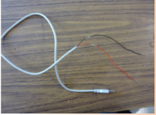 | $2.00
Wire Cutter | 1 |  | $6.70

Schematic Diagrams
Procedure
Steps # | Instructions
 | Looking at the schematics make the circuit. (This lab would be easier if the pervious labs 10 and 11 were kept.)
 | Take the inputs and play with it record when the LEDS are on and OFF on which combination of inputs
 | Make a chart of your observations

Observations
 |  | Output 1- Sum | Output 2- Carry
Input A | Input B | LED 1 On or Off | LED 2 On or Off
High (1) | High (1) | Low (0)- Off | High (1)- On
High (1) | Low (0) | High (1)- On | Low (0)- Off
Low (0) | High (1) | High (1)- On | Low (0)- Off
Low (0) | Low (0) | Low (0)- Off | Low (0)- Off

Video on procedure and observations

Extra
Looking at the Truth table for this chart there are combinations that turn ON and OFF the two LEDS. If we let LED 1 represent the LED connected to the 7408 IC chip and LED 2 represent the LED connected to the 7486 IC chip then we can better help look at the four different cases in lab 12. The first case of inputs in Lab 12 that was observed was when the two inputs were both ground (0) in this situation both LED 1 and LED 2 were OFF. In the second case of inputs in Lab 12 that was observed was when Input A was on High (1) and Input B was on ground (0) in this situation LED 2 was seen ON while LED 1 was still seen OFF. In the third case of Inputs in Lab 12 that was observed was when Input A was on ground (0) and Input B was on High (1) in this situation LED 1 was OFF and LED 2 was again seen ON. In the last situation that was observed in Lab 12 Inputs A and B were both on High (1). In this situation LED 1 was seen on while the LED 2 was seen off.
 |  | Output 1- Sum | Output 2- Carry
Input A | Input B | LED 1 On or Off | LED 2 On or Off
High (1) | High (1) | Low (0)- Off | High (1)- On
High (1) | Low (0) | High (1)- On | Low (0)- Off
Low (0) | High (1) | High (1)- On | Low (0)- Off
Low (0) | Low (0) | Low (0)- Off | Low (0)- Off

Discussion:

- Review the results in the chart form of the four cases for adding 2 binary digits?
Digit 1 | Digit 2 | Sum (EOR) | Carry (AND)
0 | 0 | 0 | 0
0 | 1 | 1 | 0
1 | 0 | 1 | 0
1 | 1 | 0 | 1

Case 1
Through the addition of two binary zeroes: 0+0=0 when two zeros are added the sum is 0 in the binary number system. And you can carry the 0 to the next significant bit.

Case 2
The Addition of 1 and 0: 1+0=1: Through the addition of 1 and 0 the sums are 1 and 0 and this can be carried to the next significant bit.

Case 3
Through the addition of 1 and 0: 0 + 1 = 1. When 0 and 1 are added, the sum is 1 and a 0 is carried to the next significant bit. (In the Binary system)

Case 4
Through the addition of1 and 1: 1 + 1 = 0 and carry 1. In the binary system, when 1 and 1 are added, the sum is 0 and the 1 is carried to the next significant bit.

- Compare question 1 with the observations in this experiment
Comparing question 1 with the observations in this experiment is simple as the results match. Remembering how the output depends on the two Inputs A and Input B and this is exactly like how the carry digits depend on the two numbers that were being added in the binary addition. This basically means that when compared both would have the same truth table. Also when looking at question 1 you can also see that the sum digits are the same as the OR gat truth table and the carry digits are exactly the same to the AND gate (that is why this is called a binary addition, so this lab was basically an addition of two gates.)
Input A | Input B | Binary Addition | Output 1- Sum digit  LED 1 On or Off | Output 2- Carry digit  LED 2 On or Off
High (1) | High (1) | 1 + 1 = 0, carry 1 | Low (0)- Off | High (1)- On
High (1) | Low (0) | 1 + 0 = 1, carry 0 | High (1)- On | Low (0)- Off
Low (0) | High (1) | 0 + 1 = 1, carry 0 | High (1)- On | Low (0)- Off
Low (0) | Low (0) | 0 + 0 = 0, carry 0 | Low (0)- Off | Low (0)- Off

- When two digits are added, a sum and a carry are obtained. For example when 1 + 0 are added the sum is 1 and the carry is 0. How should the LED outputs in this experiment be interpreted?
As for this experiment there are two LED outputs. Therefore output 1 and LED 1 should be understood as the same output value as the sum digit of two binary numbers that are being added or two inputs. Whereas LED 2 should be interpreted as the same output value as the carry digit of the binary numbers that are being added or inputs A and B. An example would be if two digits were high (1+1) the sum of this would be 0 LED will be off as output 1 is the sum digit. But the carry when both inputs are high (1+1) is 0. Therefore, LED 2 will be high or will turn on because output 2 corresponds to the carry digit. The four cases for adding two binary digits can be used to interpret the LED outputs in this experiment.

- When any 2 numbers with more than 1 digit per number are added, the addition at any place value requires the addition of 2 digits from the present value plus the carry from the previous place value. For example:

The truth table below is in direct relation to the circuit.

Input A | Input B | Sum- Output 1 | Carry- Output 2
High (1) | High (1) | Low (0) | High (1)
High (1) | Low (0) | High (1) | Low (0)
Low (0) | High (1) | High (1) | Low (0)
Low (0) | Low (0) | Low (0) | Low (0)

As provided by the integrated circuit 7486 the OR gate and the AND gate (produced by the 7408 integrated circuit) make this circuit. The truth table for the circuit above is the same to the circuit in the lab. The OR gate produces the binary sum of the two inputs when in the case of the AND gate it makes the carry of the outputs.

Conclusion:
Summarize the circuit requirements to add 2 binary digits.

A circuit that is combined with an exclusive OR gate made by the 7486 integrated circuit and the AND gate which is provided by the 7408 integrated circuit this circuit simulates the addition of two digits in the binary system. The XOR gate makes the binary sum of the two inputs mean while the AND gate makes the carry of the outputs. The first thing the circuit requires is to have pin 14 of both chips connected with the high/5 volts and pin 7 on both the IC chips must be connected to the ground/0. As for the inputs they are located on pins 1 and 2 Input a being on pin 1 and Input B on pin 2. Input A from the 7408 IC chip goes directly to the Input A/pin 1 on Picaxe 7486. Input B from the 7408 IC chip goes directly to Input B/2 pin on 7486 IC chip. Pins 3 on both the 7408 IC chip and 7486 IC chip are connected to a 740ohms resistor that is connected to the positive side of a LED. A circuit that is constructed similarly or exactly the same as in this circuit would meet the circuit requirements to add 2 binary digits. When adding 2 digits in any number base the results would be a sum and carry. In order to simulate the binary addition of both the digits a circuit must be able to generate 2 outputs from the two inputs that are there. The first would be for the sum and second would be the carry. This can be seen through this experiment as the output 1 was the sum digit and the output 2 was the carry digit. There were two inputs A and B that follow the 4 cases of adding 2 binary digits that states whether the LED that is there connected to input A and input B turns ON or stays OFF.

